**STEP1**： DOWN LOD FIRMWARE AND SOFTWARE

<https://github.com/HelloLeFei/SN_L/releases>

or contact E-Mail: [lefeirc@163.com](mailto:lefeirc@163.com)

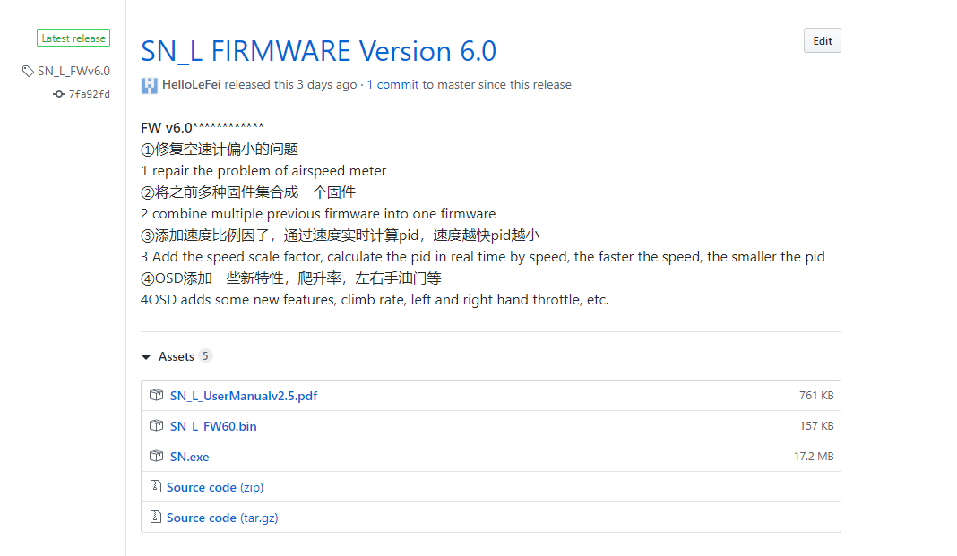

Soft ware

Firmware

**STEP2:**  connect updata tool to PC,

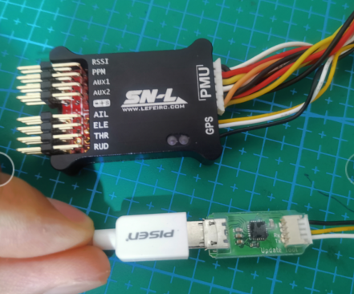

**STEP3:** install USB driver: CP210x_Universal_Windows_Driver,

**If you don't know how to install the driver, please Google, “how to install cp2104 driver”.**

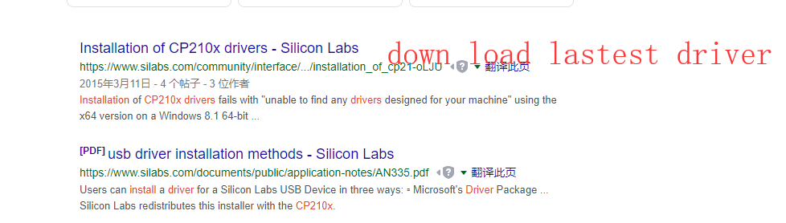

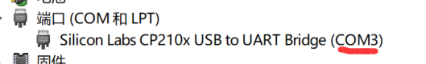

**If the installation is successful, you can see the COM ID in the device management.**

**STEP4: open software**

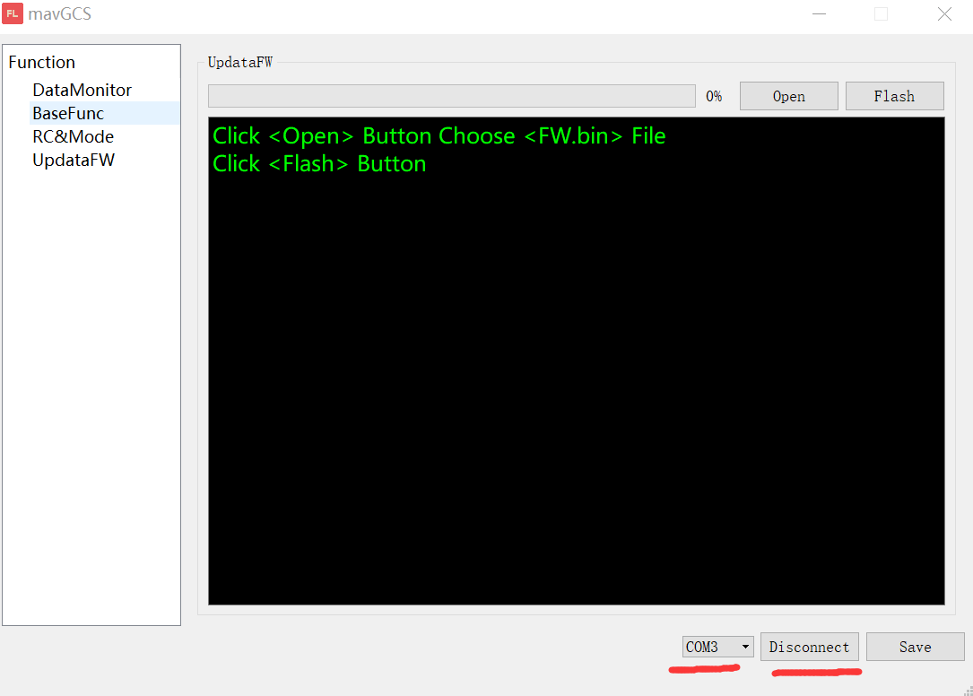

**Select COM ID and click “connect” button. If connect success, it will display “Disconnect”.**

**Then click “Open” select “****.bin” firmware.**

**STEP5:**

**Do not power on FC at beginning!!!**

**Click “flash” Button,**

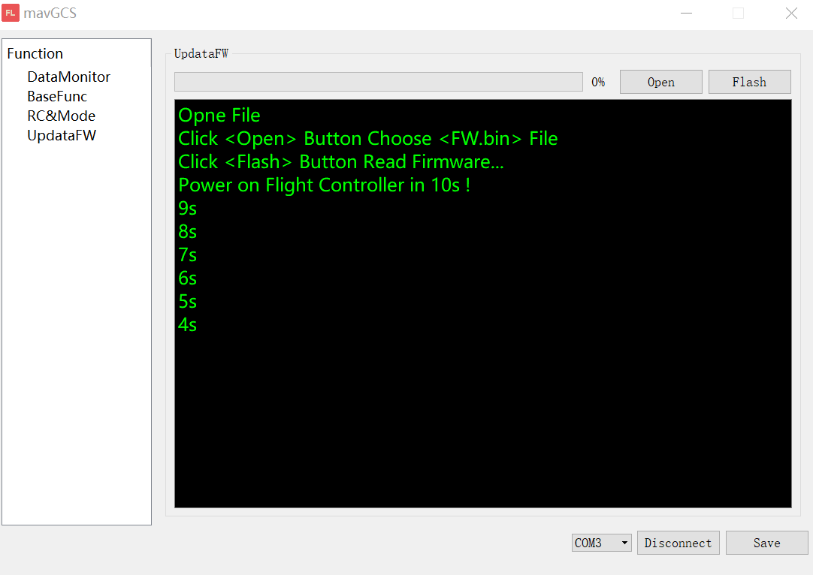

**After click, before End of countdown, you must power on FC!!!!**

**STEP6:**

**WAIT until progress 100%.**

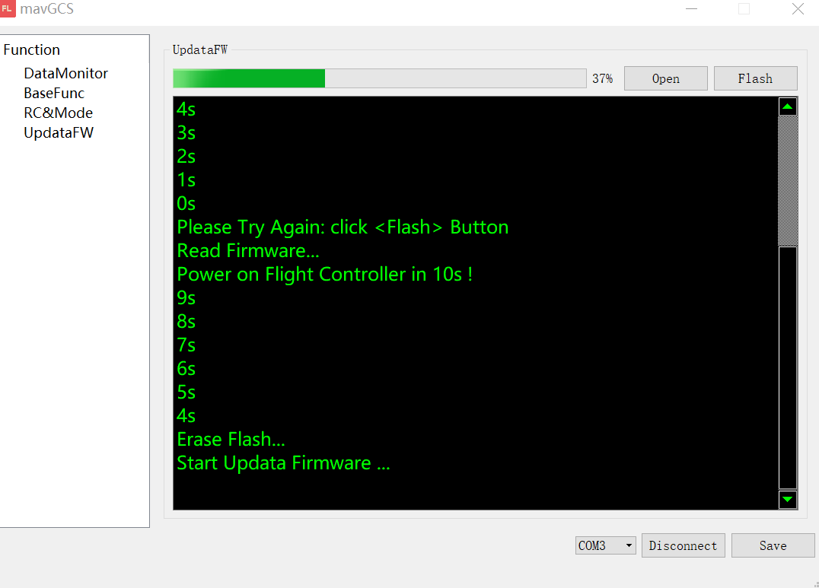

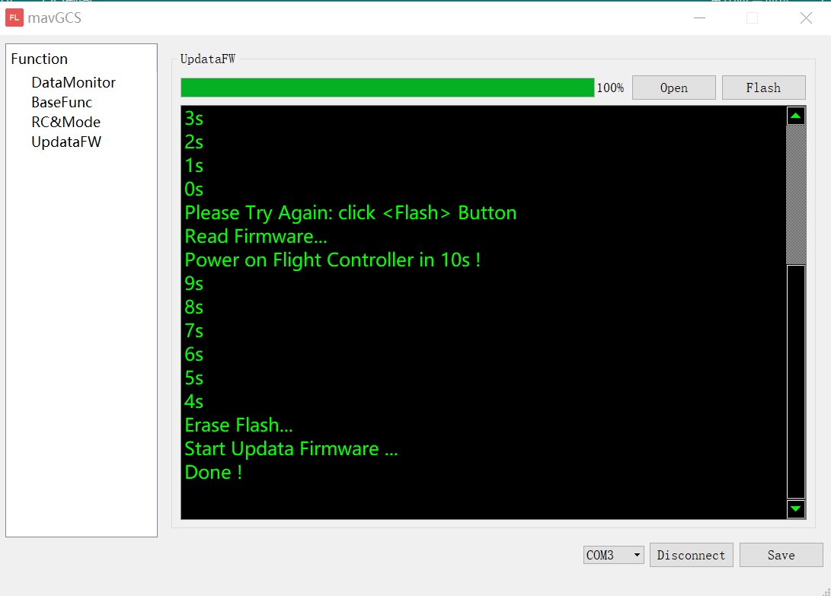

**Then you can disconnect all device, there is no need to click “Save”**

**firmware version can find at power on picture in OSD**

